

**Employee Attendance System**

**Outline:**

1. Functional Requirements
2. Non-Functional requirements
3. Technical Specifications
4. Diagrams

4.1 Use-case Diagram

4.2 Activity Diagram

4.3 Data flow diagram

4.4 ERD ( for database )

4.5 Component diagram

5. Timeline phase wise

6. Gant Chart for timeline view

**I. Functional Requirements (What the system *will do*)**

**1.1. Admin Role in Membership Management**

The Control Panel Admin will manage company memberships and perform the following actions:

1.1.1 Add New Member (Company)

1. Enter Company Name, Email, Contact Number, Number of Employees.
2. Assign Password to the newly created company.
3. Assign a Package (subscription plan) according to number of employees.
4. Activate the company account.
5. Send login credentials to the company.

1.1.2. Update Member Details

1. Change company information (Name, Contact Details, Number of Employees).
2. Upgrade/downgrade the package.
3. Reset passwords if required.

1.1.3. Delete Membership

1. Remove a company's access to the system.
2. Ensure employees under that company can no longer log in.

1.1.4. View Members

1. List all registered companies.
2. View details such as Company Name, Contact, Number of Employees, and Subscription Package.

**1.2. Company’s Role in Membership Usage**

Once a company is registered:

Company Admin (Manager) receives login credentials from the system admin.

Company Admin can:

**1.2.1** Add employee by providing:

* + - Name
    - Department
    - Designation
    - Contact information
    - Job start time.
    - End Time

**1.2.2** Update and remove employees

**1.2.3** View employees records.

**1.2.4** Search particular employee record.

**1.2.5** Manage schedules.

**1.2.6** Approve or reject employees leaves

**1.2.7** Assign roles (Manager, Employee)

**Note :** If member company has a manager also, Manager will have access of all of the above except assign roles as “Manager “ role will only be assigned by admin of member company ).

**1.2.8 . Attendance Tracking:**

* 1. Member company employees will mark attendance first when they enter for work. When they leave the office/ work place, they must have to mark attendance again.
  2. System will record employee clock-in/clock-out times and take picture at that moment when employee mark attendance..
  3. System will support for different attendance types (present, absent, late, holiday, leave).
  4. Employee will be able to request attendance adjustments (e.g., missed clock-out).

**1.2.9 . Leave Management:**

* 1. Employee requests for different types of leave (sick leave, vacation, personal leave. **When on leave, provide leave reason. If sick, provide doctor document**).
  2. Manager or admin of member company will approve or reject the leave.

**1.2.10. Reporting :**

* 1. Member company manager or admin will generate attendance reports (monthly)
  2. Member company manager or admin will export reports in various formats (CSV, Excel, PDF).

**2. Non-Functional requirements**

**2.1. Performance:**

1. Fast loading times.
2. Responsive user interface.

**2.2. Security:**

1. Secure user authentication and authorization. Every member company will have its own members list. Only and will be able to manage their own employees only.
2. Data encryption method use for passwords storing.

**3. Technical Specifications**

Web portal will be developed using following technologies:

1. Frontend: HTML , CSS , JS
2. Backend : PHP
3. Database: MySQL
4. Hosting & domain : Will be purchased

Mobile application will be developed using following technologies:

1. XML , Java
2. Database: MySQL

**Diagrams**

**Use case diagram**

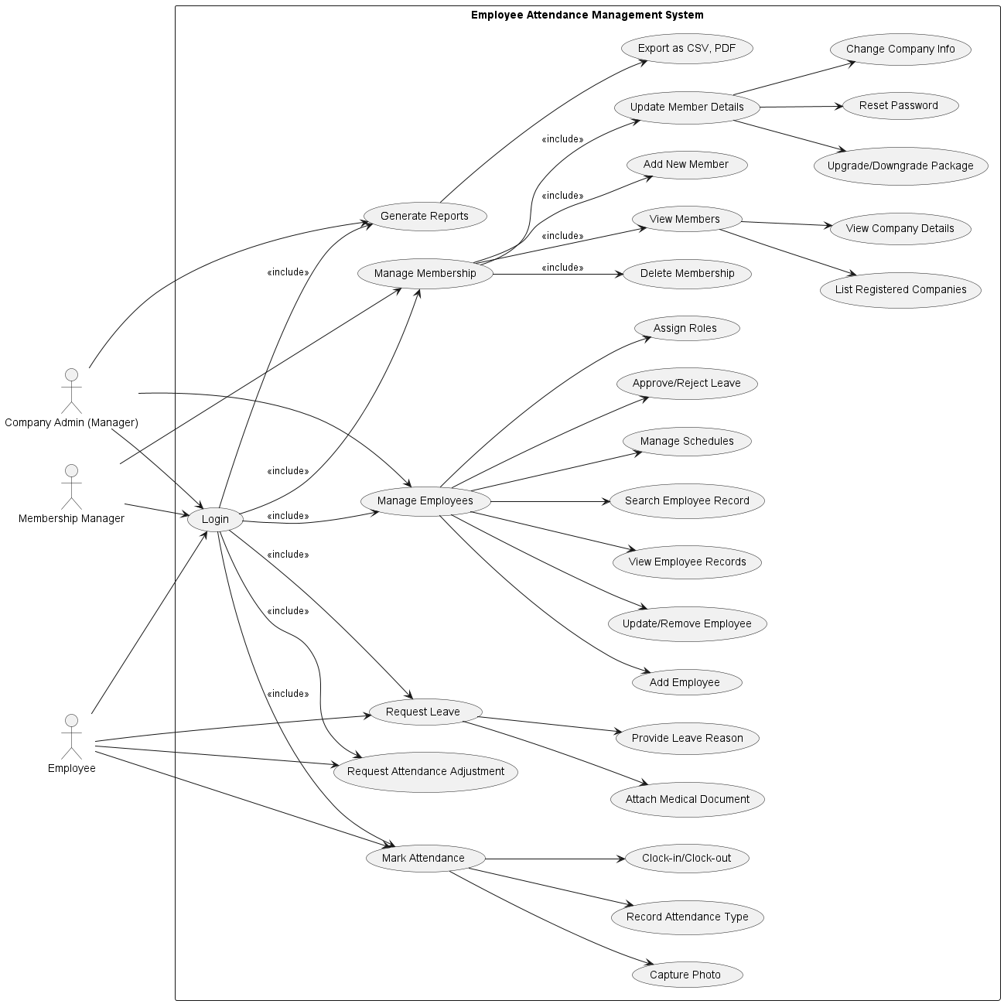

**Activity Diagram**

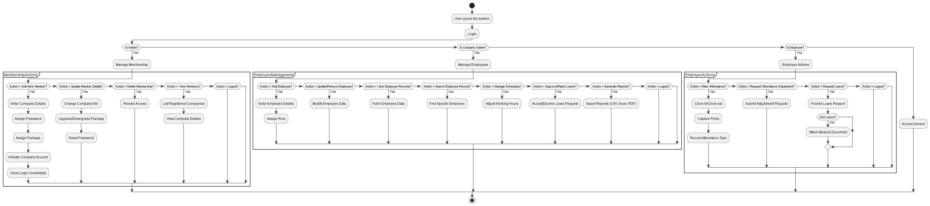

**Data flow diagram**

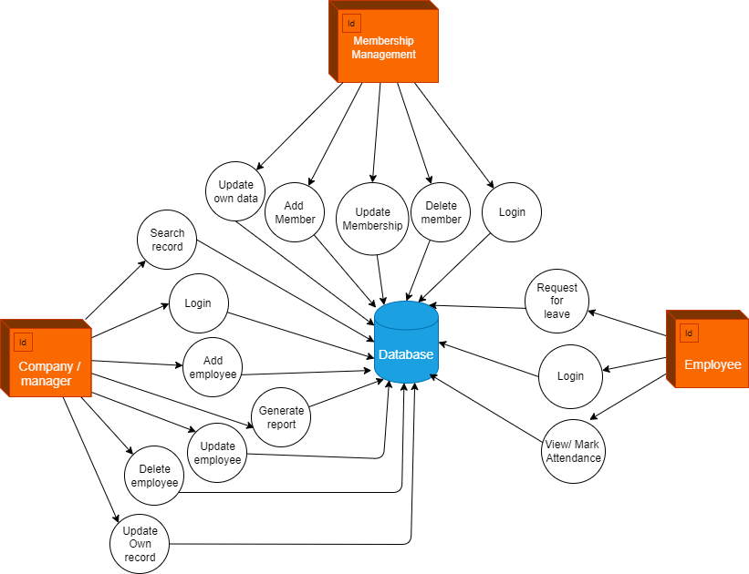

**ERD (Entity Relationship Model / Diagram)**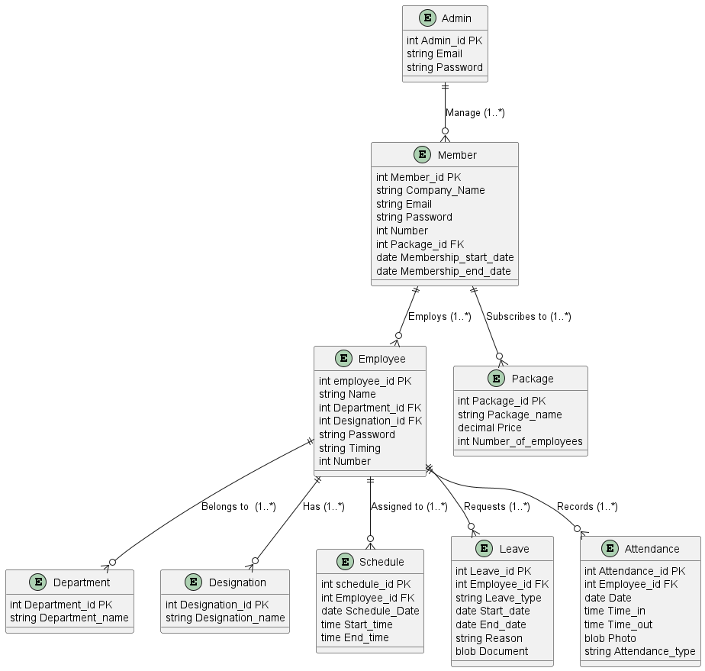

**Component diagram:**

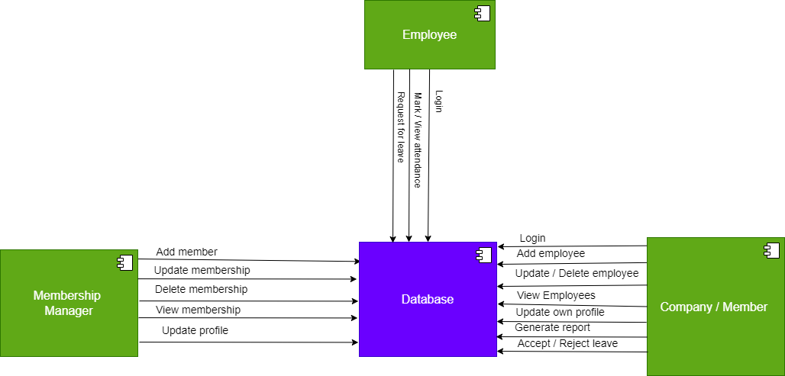

**Time-line phase wise**

**Phase 1: Project Setup and Planning:** 15 working days

1. UI/UX , mockups , prototypes designing: 12 days
2. Database Design: 2 days
3. Project Setup like IDE, GIT version control: 1 day

**Phase 2: Front-End Development:** 30 working days

1. Member Company Manager Portal : 8 days
2. Employee Portal : 6 days
3. Membership Management Portal: 5 days
4. UI/UX Polish & Refinement: 7 days
5. Accessibility Review and Implementation: 4 days

**Phase 3: Back-End Development:** 32 working days

1. User Authentication and Authorization: 5 days
2. Employee Management (Manager Module - Core Features): 7 days
3. Attendance Tracking (Core Functionality): 6 days
4. Leave Management (Functionality): 6 days
5. Reporting (Attendance Reports): 4 days
6. API Development and Integration: 2 days
7. Performance Optimization and Load Testing: 2 days

**Phase 4: Testing and QA:** 10 working days

1. Unit Testing (Ongoing)
2. Integration Testing: 4 days
3. Functional/System Testing: 4 days
4. User Acceptance Testing: 2 days

**Phase 5: Deployment and Launch:** 1 working day

1. Deployment: 1 day

**Total Estimated Time (Working Days):** 15 + 30 + 32 + 10 + 1 = 88 **working days**

Sum up of time

· **Phase 1: Project Setup and Planning:** 15 working days

· **Phase 2: Front-End Development:** 30 working days

· **Phase 3: Back-End Development:** 32 working days

· **Phase 4: Testing and QA:** 10 working days

· **Phase 5: Deployment and Launch:** 1 working day

· **Total Estimated Time (Working Days):** 88 working days

**Gant Chart for timeline view**

